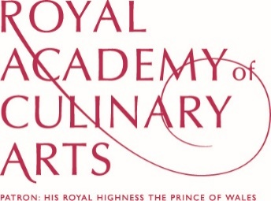
FRIENDS OF THE ROYAL ACADEMY OF CULINARY ARTS
APPLICATION FORM
FORENAME(S): |  |  | SURNAME:
POSITION & ESTABLISHMENT
(if applicable):
WORK ADDRESS:

TELEPHONE: |  |  | MOBILE:
WORK
E-MAIL:
HOME ADDRESS:

HOME TELEPHONE: |  |  | MOBILE:
PERSONAL
E-MAIL:
I wish to become a Friend of the Royal Academy of Culinary Arts please tick category below.
LIFE MEMBER  £1,500 + VAT for life subscription |  |  | ANNUAL SUBSCRIPTION  £200 + VAT |  |  | ANNUAL SUBSCRIPTION Direct Debit £200 + VAT  Please sign up online or via the DD form.
SIGNED: |  |  | DATE:

Direct Debits can be made online via https://goo.gl/vuCxhH, OR on the DD Form

Cheques should be made payable to: Royal Academy of Culinary Arts

Payment by BACS to: NATWEST A/C NO.: 00065854 SORT CODE: 56-00-03

VAT REGISTRATION NO.: GB 503 338 869

Please complete and return, with payment to:
Royal Academy of Culinary Arts, 76 Vincent Square, London SW1P 2PD

