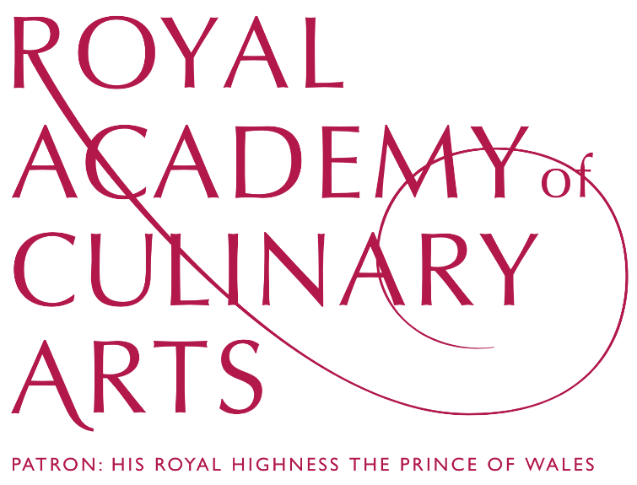

ASSOCIATE MEMBERSHIP

APPLICATION FORM

OCTOBER 16, 2014 / YUMPORIUM

LEADING THE HOSPITALITY PROFESSION BY EXAMPLE
SHAPING THE FUTURE THROUGH EDUCATION

ASSOCIATE MEMBERSHIP

The Royal Academy of Culinary Arts is Britain’s leading professional association of Head Chefs, Pastry Chefs, Restaurant Managers and quality suppliers. RACAs aims to raise the standards and awareness of food, food provenance, cooking and service, as well as the education and training of young people in the hospitality industry and the provision of career opportunities.

The Royal Academy works with suppliers of top-quality culinary products to maintain the high standards to which it is committed.

Members are united in the common purpose of supporting the future of the industry through thorough and extensive education and training. To maintain this status and influence as a working association, members are expected to invest their time in the Royal Academy’s various activities.

- There are approximately 50 Associate Members of the Royal Academy of Culinary Arts. These are carefully selected suppliers and producers of high-quality food, wine and catering products.

- There may be no more than 4 Associate Members of a particular type (e.g. butcher, fishmonger, grocer) except in exceptional circumstances.

- While no Academician is obliged to use the services of any Associate Member, we endeavour to ensure that they are kept up to date with news about the Associates and their products.

- Associate Members have the opportunity of taking a 5-minute slot at a Plenary Meeting to present their business and products.

- Associate Members have their own Steering Committee, under the Chairmanship of Gillian Thomson, which meets regularly to discuss the Associates’ participation in the Royal Academy, fundraising and other events to promote and extend its aims.

- Associate Members are included in all Royal Academy events. In addition to this, there are periodic Associates’ meetings and lunches to which members are encouraged to bring a guest.

- All Associate Members are listed in and receive a copy of the Royal Academy’s Directory of members.

- Associate Members are entitled to use the Royal Academy of Culinary Arts’ logo on company printed materials and websites, where appropriate and providing their annual subscription is fully up to date.

ENTRY REQUIREMENTS

Applicants for membership should:

- Complete the attached application form and return to the Royal Academy of Culinary Arts with a covering letter stating their reasons for wishing to join.

- List on their application form the names and establishments of at least 3 Academicians who they supply, of these 1 should propose and 1 should second the application for membership.

- Upon acceptance pay the annual subscription fee of £1,300 plus VAT, for the current year.

THE APPLICATION PROCESS

- Applications for Associate Membership are put to the Management Committee and existing Associate Members for approval.

- In the event of any objections being made to an application, the Senior Management of the Academy will discuss whether or not they are relevant.

- Competition with existing Associate Members is not deemed to be a relevant objection.

- Once a final decision has been reached no further correspondence will be entered into.

The Royal Academy’s objectives are realised through a number of core education and training initiatives aimed at all ages and stages of development, from teaching school children through to the Continual Professional Development of established chefs, pastry chefs and waiters. They are:

The Royal Academy of Culinary Arts’ Adopt A School (Charity No. 1087567)
Founded in 1990, (Chefs) Adopt a School is a national charity which teaches children holistically about food, food provenance, food growing and the environment, healthy eating, nutrition, hygiene and cookery in sessions delivered by chefs and hospitality professionals.

Royal Academy of Culinary Arts Apprenticeship
The Royal Academy of Culinary Arts (RACA) Chefs Apprenticeship is a three-year vocational course aimed at aspiring young chefs aged between 16 and 19 years old. It is a pioneering approach to delivering comprehensive training whilst enabling them to work in the finest establishments in the UK. The first RACA Chefs Apprenticeship – The Royal Academy of Culinary Arts Specialised Chefs Course at Bournemouth & Poole College – has been running since 1989 and is a three-year block release programme.
The RACA Chefs Apprenticeship, also a day release, began at Westminster Kingsway College in September 2012. In September 2015 we launched another apprenticeship programme at University College Birmingham, and in September 2016, a fifth RACA Chefs apprenticeship at City of Liverpool College. In 2014 we introduced two new qualifications in Waste Management & Sustainable Procurement to the RACA Chefs Apprenticeship programmes, which were piloted at Westminster Kingsway College and University of West London. As well as the three existing RACA Chefs Apprenticeship programmes we launched our fourth, but first, apprenticeship in Professional Restaurant Service and Management at Westminster Kingsway College in September 2014.

Annual Awards of Excellence
Begun 1983, the AAE is the most prestigious award available to young professionals in the hospitality industry today, recognising and encouraging the most talented up and coming Chefs, Pastry Chefs and Waiters. Open to young people aged between 20 and 26, the purpose of the Awards is to inspire and encourage them to achieve the highest possible standards in their chosen profession – Kitchen, Pastry or Service – and to offer them confidence and opportunities for success in their career.

Master of Culinary Arts
Launched in 1987 as the Meilleur Ouvrier de Grande Bretagne (MOGB), the Master of Culinary Arts is held every four years and rewards ability and achievement of the highest degree in Culinary Skills, Pastry and Restaurant Management & Service to those over the age of 26. Seen as the ultimate accolade awarded for outstanding craftsmanship to Chefs, Pastry Chefs and Restaurant Managers throughout the United Kingdom, the MCA is a lifetime achievement.

Sustainability
The Royal Academy of Culinary Arts’ Food Philosophy serves to inspire the holistic enjoyment of good food and encourage the purity and freshness of natural ingredients. These ingredients are nurtured through sound and ethical production methods in local seas, waters and the countryside on either our farms or in the wild. Such methods will foster not only the health and well-being of consumers but also promote a food philosophy of sustainable and ethical food cultivation that will help to address the issues that our planet faces.

Mutton Renaissance
Conceived in 2003 by His Royal Highness The Prince of Wales and officially launched in November 2004, Mutton Renaissance is the campaign to restore high-quality mutton to the menu whilst helping British sheep farmers to find a market for their older animals. The rewards are more than just a great product on the plate; we are uniting the whole chain between chef, butcher, supplier and farmer. The campaign is jointly by the Royal Academy of Culinary Arts and the Pastoral Alliance.

Other Activities
Aside from the above, the Academy participates in other activities which reflect its objectives, maintaining links with other organisations that share the common goal of securing the future of the industry.

Status
The Royal Academy of Culinary Arts is a not-for-profit organisation registered as a Company Limited by Guarantee 2014 (formerly officially a Friendly Society 1980 – 2014) Company Number 09242241. The Royal Academy of Culinary Arts Adopt a School Trust is a registered charity (Number 1087567).

The Royal Academy is privately funded by membership fees, sponsorship and donations, without which it would not exist nor continue to make a difference to the lives of so many young people in the industry. The Academy is grateful to its members, who give time so generously, allowing our work to continue.

CBE, President: BRIAN J. TURNER CBE, Chairman: JOHN WILLIAMS MBE, Vice Chairman: DAVID PITCHFORD,
Chairman Les Arts de la Table: SILVANO GIRALDIN, Chairman Associate Members: GILLIAN THOMSON,
Trustees: DAVID COUBROUGH (Chairman of Trustees), FREDERICK MOSTERT, JOHN W. VALENTINE,
Chief Executive Officer: LISA JENKINS

Board of Governors: BILL TONER (Chairman), DAVID COUBROUGH, BOB COTTON OBE, JEREMY GORING, EDWARD GRIFFITHS CVO FIH, ROBIN HUTSON OBE, PAUL JACKSON,
PETER LEDERER CBE FIH MI, JAMES R. LEE, FREDERICK MOSTERT, HARRY MURRAY MBE FIH MI, KATE NICHOLLS OBE, RAMON PAJARES OBE FIH MI,
RICHARD SHEPHERD CBE, CHRIS SHEPPARDSON, ALASTAIR STOREY OBE, MICHAEL TAYLOR, GILLIAN THOMSON,
BRIAN J. TURNER CBE, JOHN WILLIAMS MBE, KNUT WYLDE
Company Limited by Guarantee 09242241. Founded in1980 by L’Académie Culinaire de France.

APPLICATION FOR ASSOCIATE MEMBERSHIP

COMPANY NAME:
ADDRESS:
TEL:
FAX:
WEBSITE:
TWITTER:
INSTAGRAM:

NATURE OF BUSINESS:
BRIEF HISTORY OF COMPANY:
DESCRIPTION OF PRODUCTS:
LIST OF ACADEMICIANS YOU SUPPLY:

PRIMARY CONTACT

NAME:
POSITION:
TEL:
FAX:
MOBILE:
E-MAIL:
SECONDARY CONTACT (if applicable)

NAME:
POSITION:
TEL:
FAX:
MOBILE:
E-MAIL

DATE OF APPLICATION:
SIGNED:

Please complete this page and return, with your covering letter, to:
oli@royalacademyofculinaryarts.org.uk

or:
Royal Academy of Culinary Arts, 76 Vincent Square. SW1P 2PD

